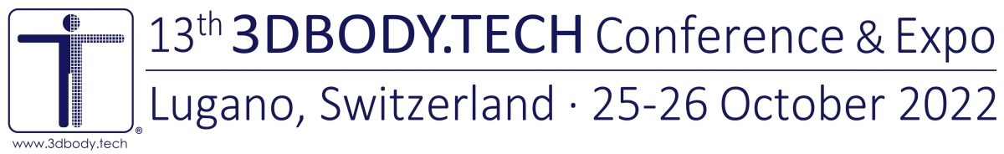
3DBODY.TECH 2022 - REGISTRATION FORM - UPGRADE
Each attendee, participant, delegate, speaker, presenter that wishes to attend (onsite or online) the
13th 3DBODY.TECH Conference and Expo has to fill a form and pay the fees before 24 October 2022.
Please save this filled form as docx or pdf file and send it to the conference office at info@3dbody.tech.
You will then receive by e-mail an invoice with details for the payment of the due registration fees.
Your registration will be confirmed only after the payment of the registration fees has been made.
Please fill with your previous registration details:
Registration number:
Name:
Affiliation/Company:
Registration:
online attendee/delegate
online undergrad. student
Upgrade to onsite registration: 100 CHF
The prices are indicated in Swiss Francs (CHF) and are inclusive of taxes when/if applicable.
Payment method:
Bank transfer with IBAN & SWIFT/BIC on CHF/EUR/USD Swiss bank account
Credit card (VISA, MasterCard, AMEX, Diners, UnionPay) by secure e-payment, +6% fees
PayPal payment system, +6% fees
Preferred currency of the invoice and payment (AMEX, Diners, UnionPay credit cards: CHF only):
CHF (Swiss Francs), EUR (Euro), USD (US Dollars)
Notes:
• Onsite registration fees include: admission to all sessions, the exhibition, coffee brakes, lunches,
access to the online conference platform with all its contents, a copy of the conference proceedings.
• Online registration fees include: access to the online conference platform with all its contents,
a copy of the conference proceedings.
• The online conference platform will be active and accessible 24h during the 2-days conference.
All recorded contents (technical sessions, exhibitors demonstrations, single presentations) will
be accessible also for 30 days after the end of the conference.
• For undergraduate students, please provide a certification or student card, as pdf or jpg file.
Discount codes, additional notes/comments:
Transfer/Cancellation/Refund Policy , Event Postponement/Cancellation Policy:
Paid registration fees are fully transferable free of charge.
Cancellations received by e-mail before Saturday 22 October 2022 will receive the refund of all paid
registration fees in CHF, less 100 CHF administration charge and 6% credit card charge (if applicable).
No refunds will be made for cancellations received after this date.
In case of event postponement or event cancellation, the following two options will be given:
• Transfer of the registration(s) without any additional costs to postponed or next year's event.
• Refund of all paid fees in CHF by bank transfer in CHF (less 6% credit card charge, when applicable).
Conference Office:
HOMETRICA CONSULTING - Dr. Nicola D’Apuzzo, Contrada Maggiore 2, 6612 Ascona, Switzerland
E-mail: info@3dbody.tech, Tel: +41.91.791.55.24

