Manuscript Template for Proceedings of 3DBST
Serge G. JONES*¹, Aris SCHMIDT^{1,2}, Carla ROSSI²
¹ Silver Research Laboratory, Los Angeles (CA), USA;
² IndiScan Ltd., Milan, Italy
http://dx.doi.org/10.15221/yy.nnn
Abstract
This document serves as manuscript template and includes all the relevant information required to format your paper for publishing in the proceedings of the conference. Please follow these instructions.

Keywords: 3d body scanning, proceedings, format
1. Introduction
The manuscript should be written in English, not have headers, footers, or page numbers. It should be in a one-column format and be 6-12 pages long. It may include color images, which will be visible in the electronic form of the proceedings; the hard copy will be printed and published in black and white.
2. Formatting of manuscript components
2.1. Paper size and margins
Paper size is A4. Top, bottom, left and right margins: 25.4mm. Do not add any header nor footer.

2.2. Fonts
Table 1 shows the font sizes and highlighting in a typical manuscript. Please use Arial font.
Table 1. Font sizes and formatting.
Manuscript style component | Format
3db title | 14 pt, bold, center
3db authors/affiliations | 10 pt, regular, center
3db doi | 9pt, regular, center
3db normal text | 10 pt, regular, justified
3db heading 1 | 12 pt, bold, left
3db heading 2 | 10.5pt, bold, left
3db heading 3 | 10pt, italic, left
3db caption | 9pt, italic, center
3db note | 9pt, regular, left
3db references | 10pt, regular, justified

2.3. Title and authors
The title of the paper is written in 14-pt bold and centered; every word is capitalized. Below the title are listed all the authors in 10-pt regular, centered. Please omit titles and degrees, such as Dr., Prof., etc. The family names are written in capital letters. The list of affiliations follows; each author’s affiliation should be clearly noted. The corresponding author should be marked with * and contact information should be added as a note at the end of the first page, in 9-pt regular. The assigned DOI (digital object identification, provided by the editor) is indicated as full link after the list of affiliations.

2.4. Section and sub-section headings
Main section headings are 12-pt bold and left-justified. Section numbers have whole numbers: 1, 2... Don’t number the “Abstract”, “Acknowledgments” and “References”. Usually used headings are the following: 1. Introduction, 2. Method, 3. Test/Data, 4. Results, 5. Conclusions.
Sub-section headings are 10.5-pt bold, left-justified and numbered 1.1., 1.2., 1.3., …

2.4.1. Sub-sub-section headings
Sub-subsection headings are 10pt italic, left-justified and numbered 1.1.1., 1.1.2., …

* s.jones@silverlab.com; +1- 222- 555; www.silverlab.com
2.5. Paper text
The text (for abstract and paper) is 10-pt and justified.

2.6. Figures and captions
Figures are centered. Please, use or insert .jpg or .gif illustrations instead of PowerPoint or graphic constructions. Please use the “In line with text” wrapping option for illustration (see figure 1). Figures are numbered with whole numbers 1, 2, 3...
Captions go below figures, centered, 9-pt italic and start with “Fig. #.” Followed by the caption text. Please avoid automatic numbering of figures.

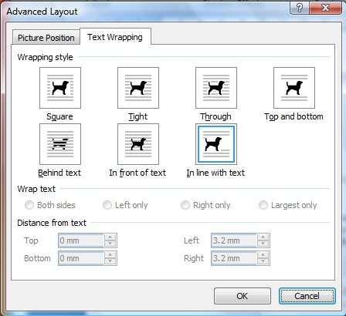
Fig. 1. Text wrapping setup for illustrations (Word 2007).

2.7. Tables and captions
Tables are centered. The caption goes above the table, centered, 9-pt italic and starts with “Table #.” followed by the caption text. Please avoid automatic numbering of tables. A table example is on previous page.

2.8. Algorithms, abbreviations, symbols
For algorithms, abbreviations, symbols used within the text, we suggest to use different fonts, as for example Courier New or Times New Romans, in order to differentiate them and make them recognizable and visible in the text.

2.9. Mathematical equations
Use the internal Word-Equation editor or insert equations as graphic objects. The equations are centered and the steps of a mathematical argument can be numbered using a right-aligned tab for clarity, as shown for example here below in equation 1.
α = (1)

2.10. References
Please use the IEEE citation style (http://en.wikipedia.org/wiki/IEEE_style) for references. Citations are numbered and citation numbers are included in the text in square brackets: single reference [1], multiple references [2,3]. All bibliographical information is included in the list of references at the end of the document, next to the respective citation number, according to the examples provided below. If available, DOI addresses are specified in the full form, for ex. http://dx.doi.org/10.19311/09.3dm044.
References
- N. D’Apuzzo and H. Luv, “Medical Applications”, in Proc. of 6th Int. Conf. on 3D-Measurements, Rome, Italy, 2009, pp. 44-50, http://dx.doi.org/10.19311/09.3dm.044.
- G. Jones et. al, "3D Scanning Systems”, in Journal of New Technologies, Vol.5, No.11, 2014, pp.35-38, http://dx.doi.org/10.75843/jnt511035.
- Body Scanning System IndiScan3D, www.indiscan3d.com., accessed 2013.
- S. Anderson et al., Digital Anthropometry, Cambridge MA, USA, MIT Press, 2008.

